## INBOX

The **Inbox** works similarly to most email applications. In the HIE, a user’s Direct address is that user’s HIE username followed by the system’s Direct Messaging address. For example, user “John_Smith” would be “John_Smith@[HIE Domain Name].com”. The exact configuration of a Direct address depends on the system setup parameters.

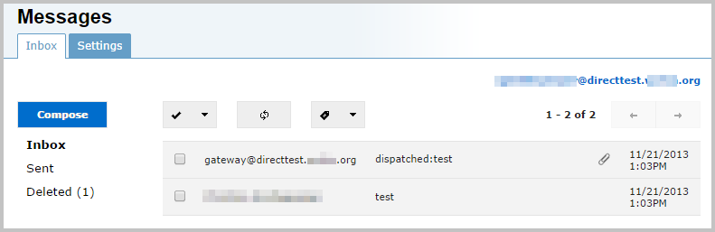

The upper right of the **Inbox** screen shows the Direct address of the user whose mailbox is currently displayed.

There are three folders which store Direct messages: **Inbox**, **Sent**, and **Deleted**. Click on any of the folder names to access those folders.

Click the refresh button to check for new messages. To delete a message from a mailbox, select the checkbox beside the message and click the trashcan button (which appears in place of the refresh button).

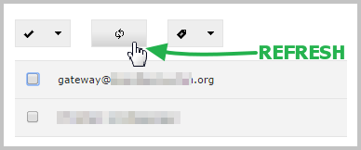 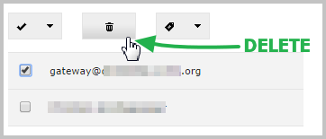

### MDN Messages

MDNs (Message Disposition Notifications) are special messages that contain information about the receipt status of Direct messages. MDNs are required by the Direct protocol, and can help diagnose message delivery issues.

When a Direct message sent from an inbox, the recipient’s Direct server responds with an MDN, indicating the message’s receipt status. These statuses are defined as follows:

* Processed MDN: indicates that a message has been received by the recipient’s system.
* Dispatched MDN: indicates a message has been delivered to the recipient.
* Failed MDN: indicates that a message has not been delivered to the recipient.

To hide MDN messages in your inbox, click on the tag button on the far right of the inbox toolbar, and select an option from the drop-down menu. Clicking on one of the check boxes will hide all messages of that MDN type.

To show MDN messages that have been previously hidden, uncheck the appropriate checkbox.

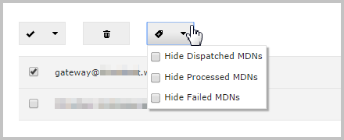

### Composing Direct Messages

Click the **Compose** button to begin writing a new message.

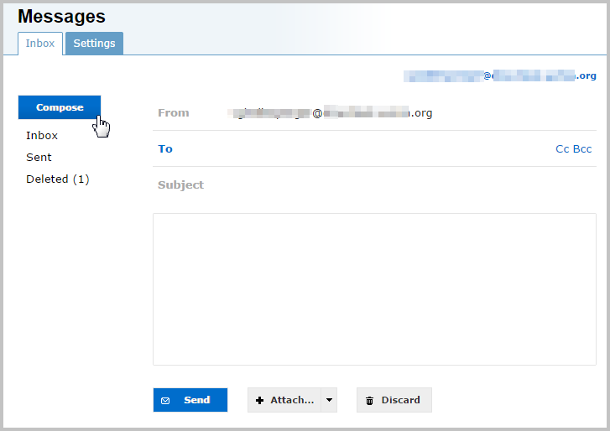

To add a recipient address the message, begin typing the first or last name of the recipient. As you begin typing, the autocomplete feature will suggest matching Direct users within your HIE directory. Click on the correct name and address to add it to the list of recipients.

If you are sending to an external Direct user, type in the Direct email address and press the enter key to add it to the list of recipients.

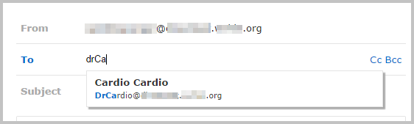

You will now see the selected address displayed below the **To** field. Click the **X** to remove an address. You may add other recipients in the **To** field, or add recipients to the **Cc** or **Bcc** fields by clicking on the appropriate links.

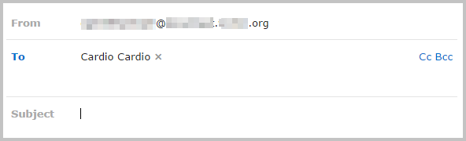

Recipient addresses can also be added by clicking on the **To** link. This will bring up the address search screen. Recipients can be found by typing in the *Search:* textbox.

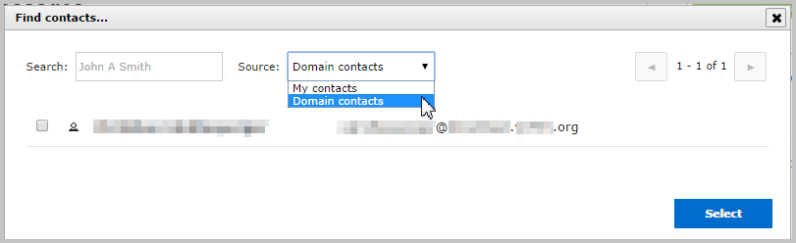

The scope of the address search can be changed by selecting an address book source from the *Source:* dropdown. Select from a list of personal contacts by clicking **My contacts**, or search all of the Direct addresses in the current Direct domain by choosing **Domain contacts**.

When the search is complete, click on the checkbox next to any Direct recipients to add, and click the **Select** button in the lower right.

Once the system has validated the trust certificate of the recipient’s Direct address, a green underline will appear. Hovering over the address will reveal the status message “This is a trusted Direct address”.

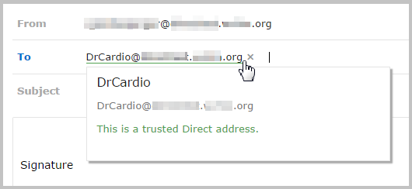

If a recipient’s Direct address cannot be verified or it does not have a valid trust certificate registered with the system, it will appear underlined with red. Hovering over the address will reveal more information about the status of the address.

Note: Direct messages may still be sent to addresses which have not been verified or are untrusted--however, be aware that any information sent to these addresses may not be secure.

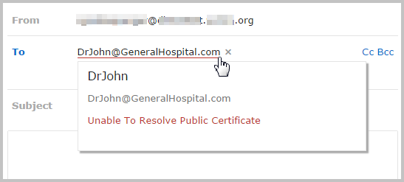

To begin composing a Direct message, enter a subject heading in the **Subject** field, and then type the message in the box below.

The toolbar contains tools for formatting message text. A tooltip will appear when hovering the cursor over a toolbar icon to describe its function.

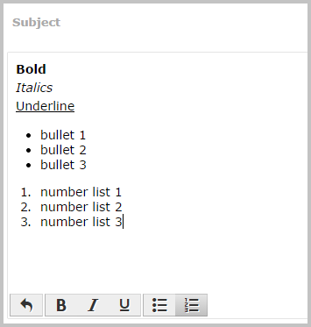

If a signature has been created, (using the Inbox screen’s **Settings** tab), it will automatically appear in the body of the message.

To delete the message without sending, click the **Discard** button, To send the message, click the **Send** button.



### Direct Message Attachments

To add an attachment to a direct message, click on the **Attach…** button below the message box, and select any number of local files to attach. Attached files will then appear in boxes below the main message.

Note: the total size of all attachments to a Direct message must be less than 6 MB.

Attachments added to a message may have their filenames changed by clicking on the small pencil icon and typing in a new filename. Attachments can be deleted from a message by clicking the small trashcan icon.

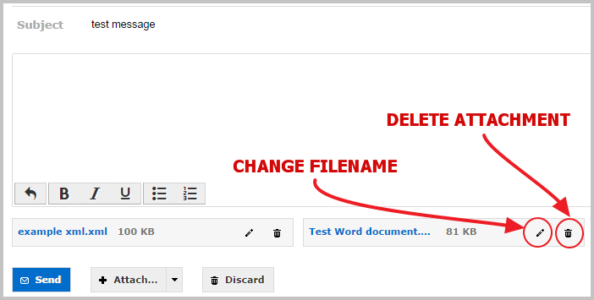

When a Direct message with an attachment is received, it can be downloaded by clicking the download icon:

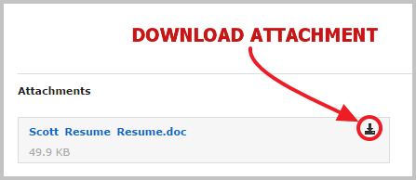

Certain supported document formats can be viewed in an attachment viewer window while on the Inbox screen. Supported files currently include PDF, CDA, XDM.ZIP, JPG, PNG, BMP, HTML, and TXT.

Click on the attachment filename to open the attachment viewer. The file being viewed can be downloaded by clicking the download icon in the upper left (next to the filename). To return to the Inbox, click the **X** in the upper right of the attachment viewer window.

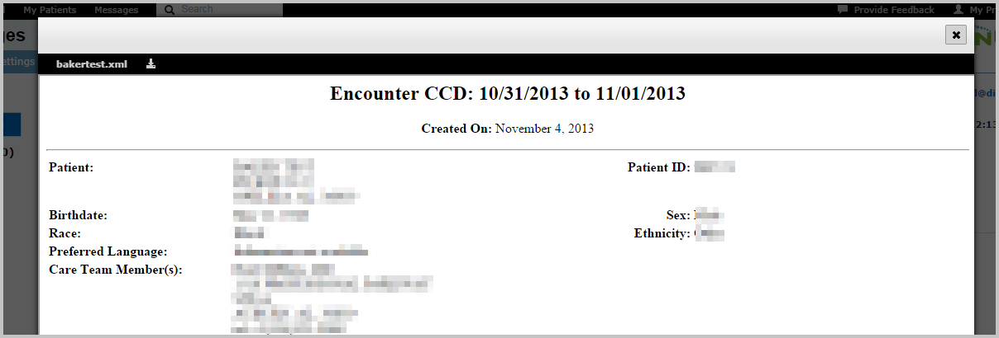

Note: If a file is not in a format supported by the viewer, a message will appear to indicate that fact. The displayed message will inlcude a link to allow the file to be downloaded instead.

If a file opened in the attachment viewer contains a number of other files (as in a zip file), a dropdown menu will allow the selection of specific files stored within the main file. Select the file to be viewed from the dropdown list, and it will appear in the attachment viewer window.

